

HTU Upskilling Program : DataScience Track

Capstone Project : Prediction of car price

Student Name : Abdallah Al-Qise

Date : 15th Jan 2023



* Introduction

Car price can be hard to determine because it depend on many factors, the aim of this project to make a model to predict the car price.

* Problem

## We will be predicting the car price using it’s dimension, engine size ,and engine location . this project will help the car buyer to not to get scammed and know the price of the car.

* Data set
* Source: Kaggle

## <https://www.kaggle.com/code/goyalshalini93/car-price-prediction-linear-regression-rfe/data>

## Attribute Information

* Car_ID: Unique id of each observation (Interger)
* Symboling: Its assigned insurance risk rating, A value of +3 indicates that the auto is risky, -3 that it is probably pretty safe.(Categorical)
* carCompany: Name of car company (Categorical)
* fueltype: Car fuel type i.e gas or diesel (Categorical)heart_disease: 0 if the patient doesn't have any heart diseases, 1 if the patient has a heart disease
* aspiration: Aspiration used in a car (Categorical)
* doornumber: Number of doors in a car (Categorical)
* drivewheel: type of drive wheel (Categorical)
* enginelocation: Location of car engine (Categorical)
* carlength: Length of car (Numeric)
* carwidth: Width of car (Numeric)



* curbweight: The weight of a car without occupants or baggage. (Numeric)
* enginetype: Type of engine. (Categorical)
* cylindernumber: cylinder placed in the car (Categorical)
* enginesize: Size of car (Numeric)
* fuelsystem: Fuel system of car (Categorical)
* compressionratio: compression ratio of car (Numeric)
* horsepower: Horsepower (Numeric)
* peakrpm: car peak rpm (Numeric)
* highwaympg: Mileage on highway (Numeric)
* citympg: Mileage in city (Numeric)
* price (Dependent variable): Price of car (Numeric)
* Data visualization
  + Python:
  + 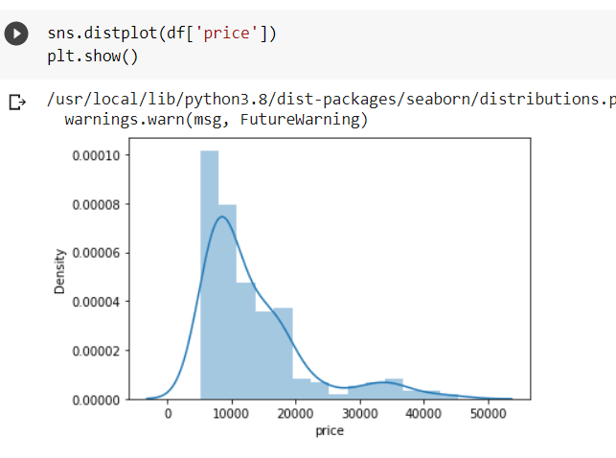



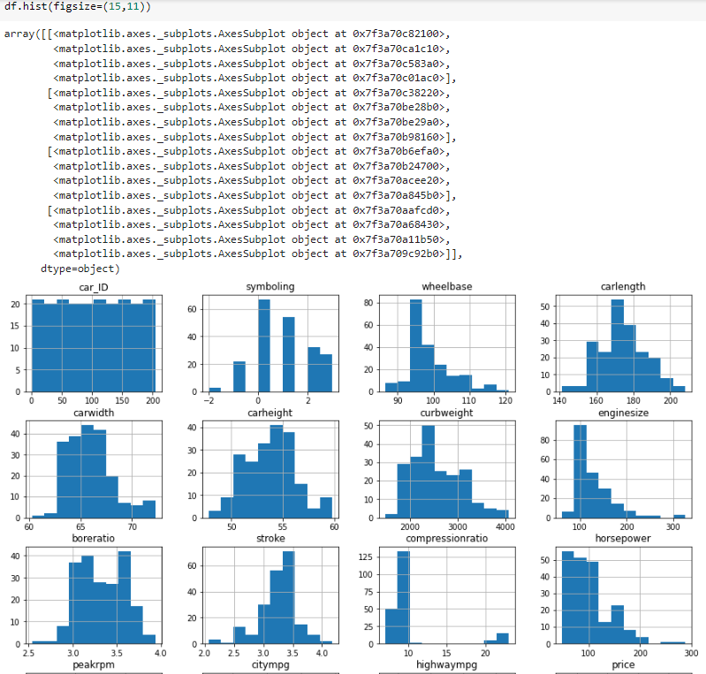

## 

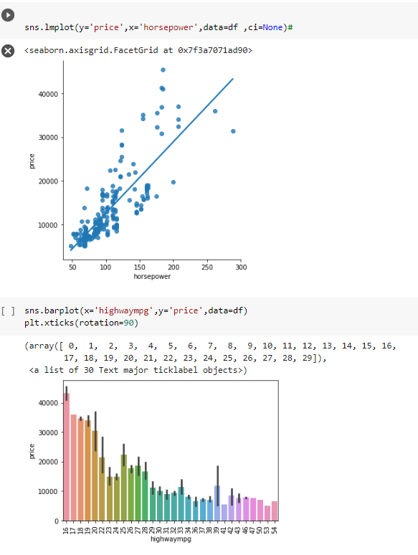

Model

* Linear regression (scikit learn)
* Decision Tree (scikit learn)
* Random forest (scikit learn)

Results

* 90.2599568345554%
* 81,12818305582723%
* 90.17831286491943%

Github link: <https://github.com/AbdallahAlqisie/Car-price-project->